

Chemistry ATAR 3+4

Acids & Bases Test

TOTAL = 54 Marks

DO NOT MARK THIS PAPER

Please use the Multiple answer sheet for part 1 and the answer booklet for part 2.

PART 1 : Multiple Choice (10 Marks)

Q1. Which of the following volumes of a 0.040 mol L⁻¹ potassium hydroxide solution is required to react exactly with 20.0 mL of a 0.010 mol L⁻¹ diprotic acid?

A. 1.0 mL
B. 5.0 mL
C. 10.0 mL
D. 20.0 mL

Q2. Which of these salts will give a basic solution when added to water?

- NH₄NO₃
- NH₄CH₃COO
- Ca(NO₃)₂
- CaS

Q3. Which of the following is most UNLIKELY to act as both a Brönsted - Lowry acid or base?

A. OH─
B. HPO₄^{2─}
C. HS─
D. NH₄⁺

Q4. Which statement best describes the equivalence point in a titration between a strong acid and a strong base?
- A. The point at which the first sign of a colour change occurs
B. The point at which equal moles of acid and base have been added together
C. The point at which equal moles of H⁺ ions and OH– ions have been added together
D. The point at which the rate of the forward reaction equals the rate of the reverse reaction

Q5. All the following are amphoteric except:

- HSO₄¹⁻
- HPO₄²⁻
- H₂PO₄¹⁻
- PO₄³⁻

Q6. Sulfuric acid (H₂SO₄) and nitric acid (HNO₃) are both strong acids. Ethanoic acid (CH₃COOH) is a weak acid.
20.00 mL solutions of 0.10 M concentration of each of these three acids were separately titrated with a 0.10 M solution of sodium hydroxide (NaOH),
In order to reach a pH 7 neutralisation reading.

A. all three acids would require the same amount of NaOH.
B. HNO₃ would require more NaOH than CH₃COOH but less than H₂SO₄.
C. H₂SO₄ and HNO₃ would require the same amount of NaOH but CH₃COOH would require less.
D. CH₃COOH and HNO₃ would require the same amount of NaOH but H₂SO₄ would require more.

Q7. Which of the following examples represents an acid-base reaction?

A. NH₄⁺_{(aq)} + OH─ _{(aq)} → NH_{3(aq)} + H₂O_{(l)}
B. 2NO₃─_{(aq)} + 2H⁺_{(aq)} + 3H₂O_{2(aq)} → 2NO_{(g)} + 3O_{2(g)} + 4H₂O_{(l)}
C. 2K_{(s)} + 2H₂O_{(l)} → 2K⁺ _{(aq)} + 2OH─_{aq)} + H_{2(g)}
D. Ca²⁺_{(aq)} + CO₃^{2─}_{(aq)} → CaCO_{3 (s)}

Q8. Methanoic acid and azoic acid are both weak acids with the following acidity constants (equilibrium constants).
Ka in M at 25⁰C
methanoic acid (HCOOH) 1.82 × 10^{─4}
azoic acid (HN₃) 1.91 × 10^{─5}

Two separate solutions were prepared, one of 0.1 M methanoic acid and the other of 0.1 M azoic acid.
Which one of the following would be present in the highest concentration at 25ºC?

A. HN₃ in the azoic acid solution
B. N₃─ in the azoic acid solution
C. HCOOH in the methanoic acid solution
D. HCOO─ in the methanoic acid solution

Q9. Acid X is 0.1 mol L^{–1} hydrochloric acid. Acid Y is 1.0 mol L^{–1} ethanoic acid.
How does acid X compare with acid Y?
- A. X is weaker and more dilute than Y.
- B. X is stronger and more dilute than Y.
- C. X is weaker and more concentrated than Y.
- D. X is stronger and more concentrated than Y.

Q10. Pure water undergoes self-ionisation. The equilibrium constant for the reaction at 95ºC is 4.8 x 10^{─13}. This corresponds to a pH of 6.2. Which of the following statements is true?

A. At 95ºC the water is acidic.
B. At 95ºC the water is neutral.
C. At 95ºC the water is basic.
D. The pH has been worked out incorrectly.

PART 2 : Short Answers (44 Marks)

1. Write net IONIC equations for any reaction that occurs in the following making sure to include phases in your answer: Also write full observations.
NB: If no reaction occurs you must state this.

a) Calcium hydroxide solid and sulphuric acid.

b) Strontium oxide powder and phosphoric acid.

c) Nitric acid and copper carbonate solution.

d) Acetic acid solution and magnesium metal.

[12 marks]

2. Rewrite the following equations labelling the acids and bases with either an “A” or a “B” and show proton donation and acceptance with an arrow for both the forward and reverse reaction. State the conjugate acid/base pair and conjugate base/acid pair for each reaction:

- CN⁻¹ + H₂O HCN + OH⁻¹

- CH₃COOH + S²⁻ CH₃COO⁻¹ + HS⁻¹

[4 marks]

3. Is a lithium oxalate solution acid, basic or neutral? Explain with the aid of a hydrolysis equation.
[2 marks]

4. The K_{a} values for two acids are given in the table below:

Acid | K_{a} @ 25°C
H₂C₂O₄ | 5.4 x 10⁻⁵
H₃PO₄ | 7.1 x 10⁻³

NB: These are the K values for the 1st ionisation only! i.e. K_{a1}

a) Of the two acids which is the strongest? Justify your answer using the K_{a} values.

b) Write equations to represent the first ionisation of each acid.

[4 marks]

5. Calculate the pH of (assume 25⁰C):

- A solution of 0.320 grams of HCl in 250mL of water.
[3 marks]

- 75ml of 0.15M NaOH is mixed with 2.5g of powdered Ba(OH)₂
[6 marks]

6. A 4.65g sample of pure NaOH_{(s)} is dissolved in 200mL of distilled water and then added to 626mL of 0.15 mol.L⁻¹ H₂SO_{4(aq)}. Determine the pH of the mixture when the reaction is complete. Also state the limiting reagent.
[7 marks]

7. Titrations are a very important analytical technique in Chemistry. Unfortunately, acids, bases and salts are generally all clear and colourless in solution, so the end point of a titration cannot be signified by a colour change as in a redox titration. We need to select an indicator which changes colour for us. However, the selection of the correct indicator is based on a few factors.

a) On your answer sheet, write down the missing entries a to f from the table below.
[3 marks]

 | Strong Base | Weak Base
Strong Acid | 1. pH at end point = a  Indicator = b | 3. pH at end point = e  Indicator = f
Weak Acid | 2. pH at end point = c  Indicator = d

b) The following titration curves are drawn for titrations 1,2 and 3 above. Match the titration to the correct curve. Write your answer in the form
“1A” or “1B”etc.

A B C

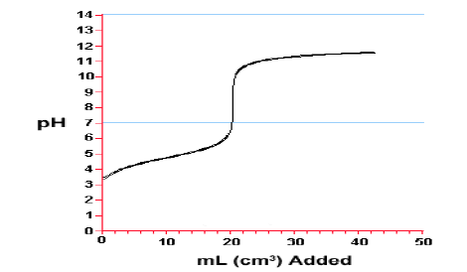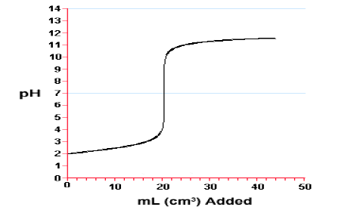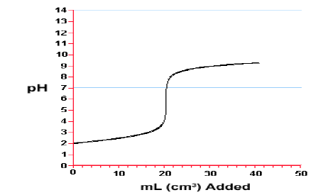

[3 marks]

END of PAPER

